**CHAPTER 3**

PROJECT METHODOLOGY

This chapter explains the details of the software development methodology which was implemented during the development of this project.

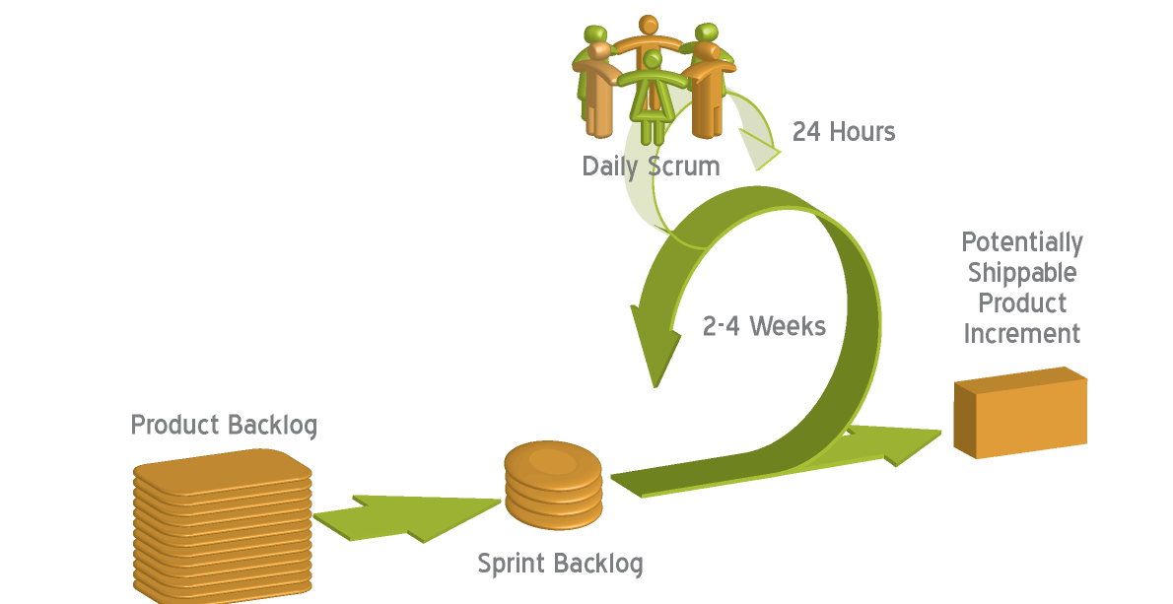The developers have chosen to apply the Scrum Agile Method during the development of the Online Appointment and Patient Profiling System. The developers chose this software development model because the system consists of different modules which are sub-deliverable. The diagram below represents the development cycle of the system.

Figure 3.1 Scrum Process

**3.1 Scrum**

Scrum is an agile methodology that can be applied to nearly any project; however, the Scrum methodology is most commonly used in software development. The Scrum process is suited for projects with rapidly changing or highly emergent requirements. Scrum software development progresses via a series of iterations called sprints, which last from one to four weeks. The Scrum model suggests each sprint begins with a brief planning meeting and concludes with a review. These are the basics of Scrum project management.

## 3.2 Product Backlog Phase

During the product backlog phase, the development team visited the clinic to have a conference with the resident dentist personally. At the first phase of the discussion, the development team together with the dentist discussed what the major modules of the system would be. After discussing thoroughly, both parties came up with an agreement that the major modules of the system would be the patient profiling, online appointment reservation, scheduling, and report generation.

The second phase of the discussion was concerned with determining the requirements for each major module. After determining all the requirements specification for each major module, the team then asked the client to set the order and priority for the major modules and she came up with the sequence (arranged from the highest priority to the lowest priority): patient profiling, online appointment reservation, scheduling, and report generation. These major modules are the product of the product backlog phase.

## 3.3 The Sprint Backlog Phase

After the team have collaborated with the client and have gathered relevant information with regard to the system’s major modules and the level of priority for each module, the team transfers the module with the highest prioritized goal to the sprint backlog. The team then creates specific tasks for the transferred module with the highest priority. The team then sets the required time to finish these specific tasks and informs the client with regard to the duration of these tasks. The list specific tasks created for each major module is the product of the sprint backlog phase.

## 3.4 The Sprint Phase

After breaking down the major module from the product backlog into specific tasks, each task on the list of specific tasks were then assigned to the different developers of the team. The specific tasks were concerned with the design of the user interface for the modules, the analysis and design for the database, and the implementation of the required functionalities to these modules. Each task was allotted with a 3 day deadline. The whole sprint cycle is a focused effort for a 30-day period toward fixed goals which is to finish the list of specific tasks on the sprint backlog.

## 3.5 Daily Scrum

The team had daily scrum meetings to keep track of the progress on the tasks assigned to each member of the team. Meetings were done through personal meetings and sometimes through online messaging mediums. A daily scrum is an open forum where the team discusses the problems and difficulties which were encountered with the assigned tasks. After determining the problems and difficulties, each member would then suggest solutions on how to solve these problems and difficulties to other members of the team. This activity will provide an insight into how the project is progressing and provides a venue for each member of the team to provide insights to one another.

## 3.6 Demonstration and Evaluation

Each Sprint will finish with a demonstration wherein the functioning software is run before the client. The client will then provide comments, insights, or will suggest changes if ever he/she wants to add, change, or remove a functionality of the delivered software. This is the basis for an evaluation meeting that in turn is the starting block for the next Sprint.